**Module 2 - Lesson Assignments**

**To do**

**Lesson Assignment 1.1**  
Browse the web to find examples of persuasive design.

Look for examples of:

* Credibility
* Social Proofing
* Reciprocity
* Increasing early engagement
* Scarcity
* Time constraints

**Lesson Assignment 1.2**  
Compare how different websites display on various screen sizes and devices. Choose a few apps on your phone that you regularly use that have websites you can browse on your desktop.

1. Browse the website on your desktop/laptop and see how they function and relate to you as the user. Where is the navigation? How does the site make you feel?
2. If you have a tablet, try browsing on your tablet and see what changes they have made. If you don't have a tablet you can use Chrome DevTools to make the page display as though it's on a tablet.
3. Browse the site on your phone's browser. What functionality or content, if any, have they removed from the page? How have they adapted to the different screen size?
4. Open the app and see how the interaction differs on there. Do they allow different gestures to the phone's browser? What makes the app better or worse than the browser view?

**Lesson Assignment 1.3**  
Perform a card sorting for your Shadowball website. Please note that this assignment will form part of your module assignment. Take photos of the card sort to help you remember what you discussed and to include in the module assignment report.

1. Get users/friends to assist you with your card sort. If you are struggling to find someone to participate in your card sort, please get in touch with your tutor.
2. Cut out cards and write tasks/pages on them. What pages will you find on your website? What tasks might users want to complete on the site?
3. Write out around 15-30 cards. This number can vary depending on your site, but enough cards to give the users something to work with.
4. Ask the user to sort the cards into piles.
5. Ask them to provide category names for the individual piles.
6. Reflect on process and how you can see the information architecture starting to take place.

**Lesson Assignment 1.4**  
Draw a UI flow diagram for two different flows in [Netflix.](https://www.netflix.com/)

1. If you are a user, log out and follow the signup process. See how they use progressive disclosure to bring you further down the process. You don't need to complete the process, so don't worry about having to put credit card details in.
2. Browsing movies (optional). If you are a user, take some time to see how Netflix encourages you to stay 'in the flow' and continue browsing around until you've found the right film/series.

**Lesson Assignment 1.1**

**Persuasion and Design Values**

**Credibility**

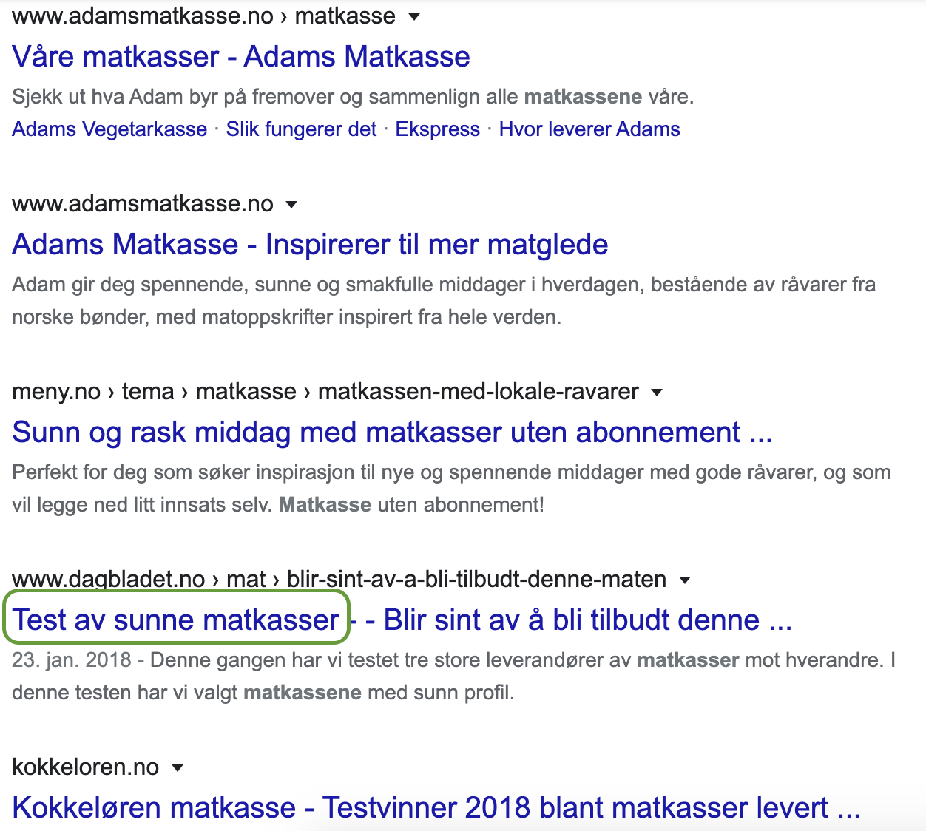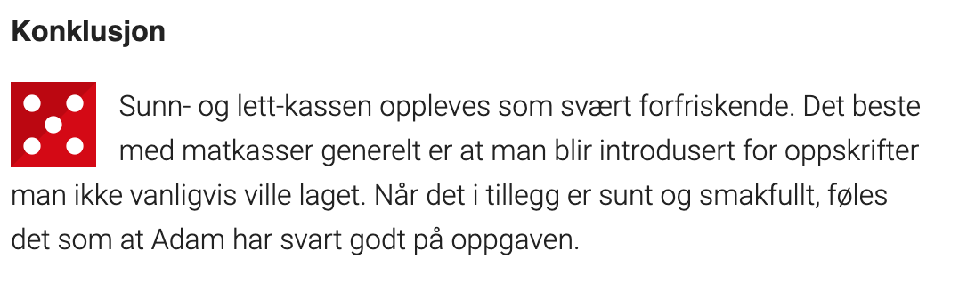



**Social Proofing**

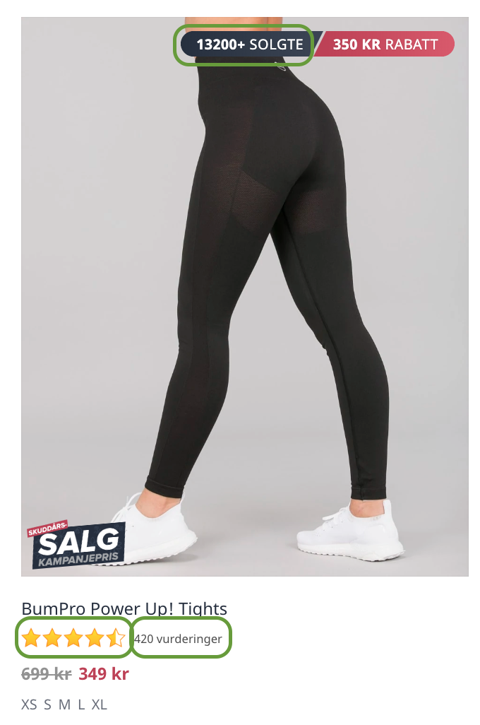

**Reciprocity**

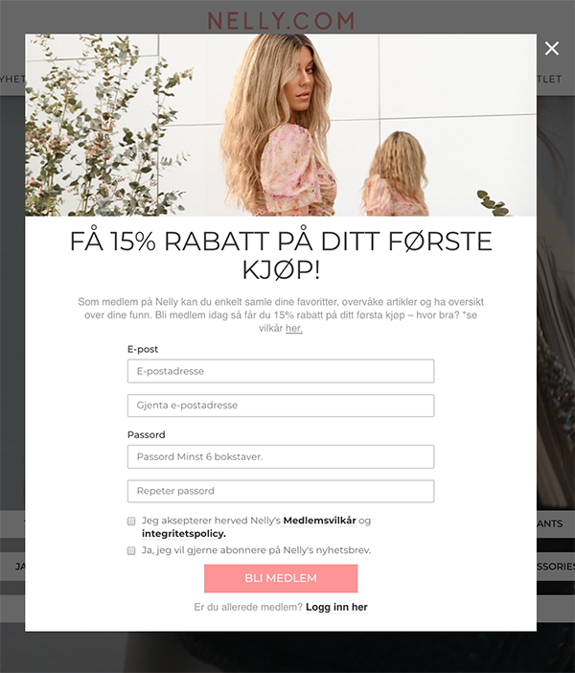

**Increasing early engagement**

The previous example popped up after about 3 clicks, which I find to be an appropriate time before engaging. This next one pops up immediately after opening the page, which is bad. How do I know I like this recipe, let alone all other recipes they might send me down the line?

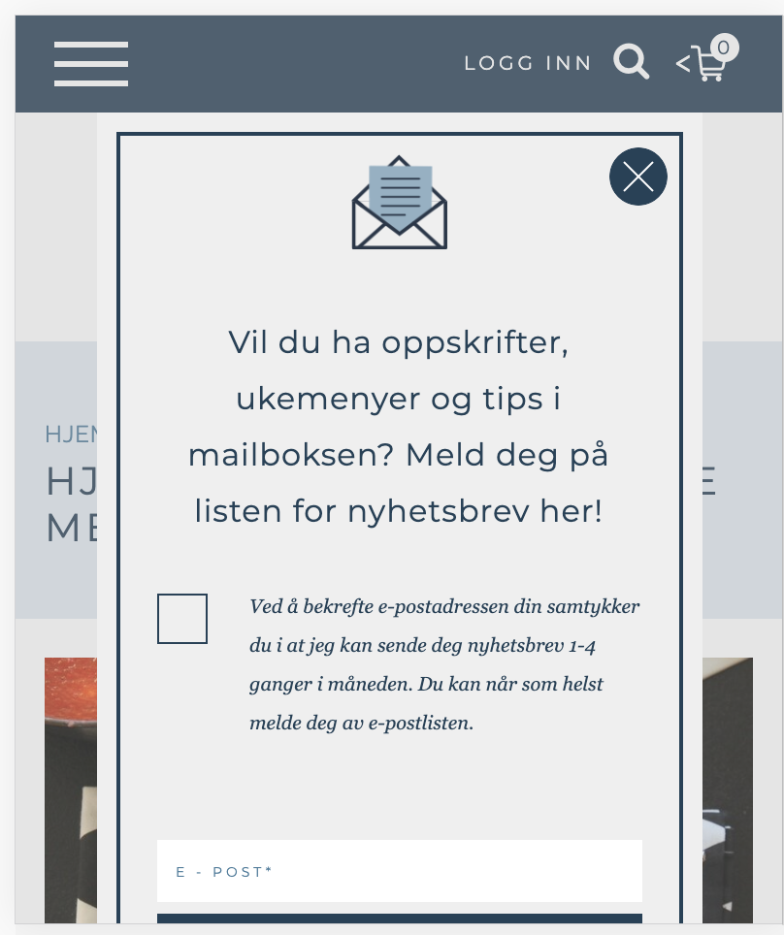

**Scarcity**

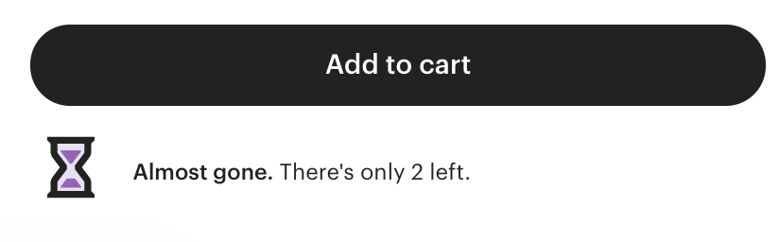

**Time constraints**



**Lesson Assignment 1.2**

**Context and Platforms**

**asdasdasd**

asd

**Lesson Assignment 1.3**

**Info Architecture and Design for the Middle Introduction**

**Card sorting**

Shadowball as of today

* shop
  + shadow ball’s
    - pdp - all shadowball ball related products
  + collector shadow ball’s
    - pdp
  + rugby ball’s
    - pdp
  + booster program’s
    - products
      * pdp
  + headgear
    - products
      * pdp - although not only headgear
  + shadowwall
    - products
      * pdp
  + academy
    - products
      * pdp
  + clothing
    - products
      * pdp
* academy
  + landing page/sign up
* about us - dropdown menu, only one
  + introduction
  + shadowball videos
  + news
    - all
    - blog
    - retail news
    - school
    - training
* how does it work
  + landing page
* contact us
  + landing page/contact form

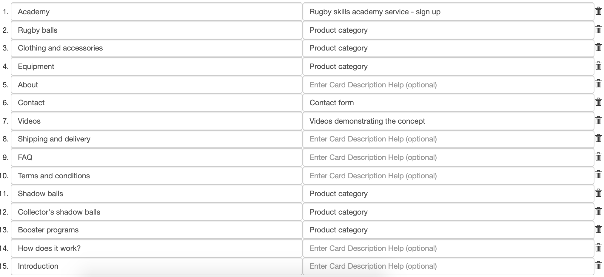

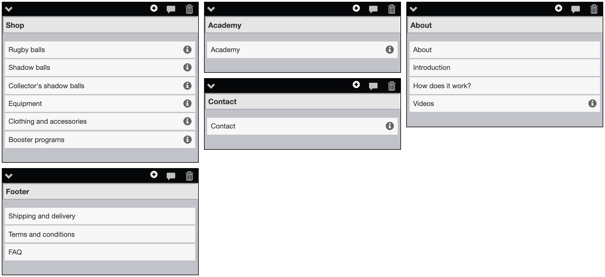

**Lesson Assignment 1.4**

**Design the Flow**

**Netflix flow diagram**

